CANTEEN MENU  
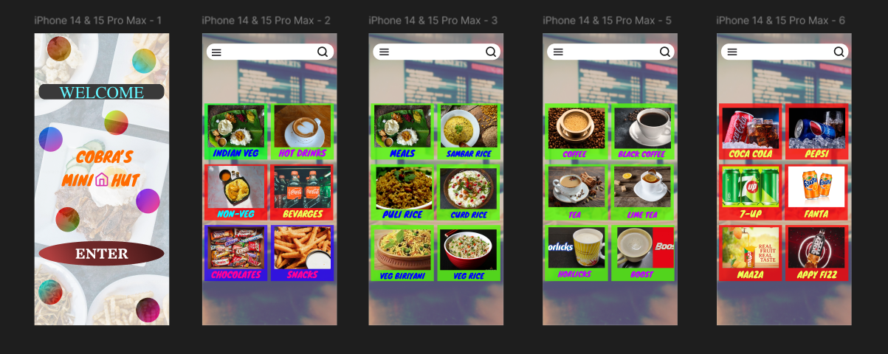

Aim: To Create Canteen Menu

Procedure:

### **Step 1: Set Up Your Canvas**

1. **Create a New File**:
   * Open Figma and create a new design file by clicking on the **New File** button.
2. **Set Up the Frame (Artboard)**:
   * In Figma, use a **Frame** as your artboard.
   * To create a frame, press **F** (or click on the Frame tool in the toolbar) and draw your desired size. For a standard menu, you might want to use an A4 or letter-size frame (210mm x 297mm or 8.5in x 11in).
   * Name your frame "Canteen Menu" or similar in the **Layers** panel for easy organization.

### **Step 2: Design the Header (Title Area)**

1. **Add the Menu Title**:
   * Click on the **Text Tool (T)** and create a text box at the top of the frame.
   * Enter a title like **"Canteen Menu"** or something more specific (e.g., "Daily Specials").
   * Use a large, bold font for the title to make it stand out. You can select fonts in the properties panel. Popular fonts for menus are **Montserrat**, **Roboto**, or something playful like **Lobster**.
2. **Style the Title**:
   * Adjust the font size, color, and spacing for the title. Consider using a bright color or background for emphasis.
   * You can use **Alignment** tools to center the title.
3. **Add a Decorative Element**:
   * Consider adding icons or graphics (like food icons or simple borders) to enhance the header. You can use the **Icon** feature in Figma or import custom images/icons.

### **Step 3: Organize the Menu Sections**

1. **Divide the Menu into Sections**:
   * The next step is to organize the menu into sections like **Starters**, **Main Courses**, **Beverages**, and **Desserts**.
   * You can use **Text** to label each section clearly.
   * Add a smaller heading for each section (e.g., "Starters", "Sandwiches", "Salads", etc.) and style them with a consistent font and size.
2. **Create Divider Lines**:
   * Use the **Line Tool (L)** or a **Rectangle** (set to a thin height) to create horizontal lines between the sections for a clean, structured look.

### **Step 4: Add Menu Items**

1. **List Menu Items**:
   * For each section (e.g., "Starters"), use the **Text Tool (T)** to create a list of items.
   * Format the item names in a consistent font size.
   * Leave space for the price next to the item name. This can be aligned to the right side for clarity.
2. Example format:
   * **Veg Spring Roll** … $5.00
   * **Chicken Wrap** … $7.50
3. **Add Icons or Illustrations**:
   * You can add small icons next to the menu items to represent the food type (e.g., a burger icon for a burger menu item). To do this:
     + Use Figma’s **Icon Plugin** (e.g., "Feather Icons" or "Material Icons") or upload custom images.
   * Align icons next to text for visual appeal.

### **Step 5: Add Pricing and Descriptions (Optional)**

1. **Include Item Descriptions** (optional):
   * If you'd like to add descriptions for each menu item, use the **Text Tool (T)** and place a small description below each item. Make sure to use a smaller font size for descriptions.
2. **Add Prices**:
   * As mentioned, the prices can be placed to the right of the menu items, either as text or inside a small price box.
   * You can use Figma's **Auto Layout** feature for dynamic alignment of menu items and prices.

### **Step 6: Style the Menu**

1. **Color Scheme**:
   * Choose a color palette that fits the theme of the canteen (e.g., warm colors like red, orange, yellow for fast food; greens and earth tones for healthy meals).
   * Use colors for headings, dividers, and backgrounds. You can create a background color or use a gradient for the frame.
2. **Typography**:
   * Use different font weights to create hierarchy. For example, larger, bolder text for section headings and a smaller, lighter font for item names and descriptions.
   * Maintain a consistent font style throughout the menu for a clean, professional look.
3. **Spacing and Alignment**:
   * Use Figma’s **Auto Layout** to ensure proper spacing between items, sections, and the alignment of text and prices.
   * You can also manually adjust spacing with the **Align** tool.
4. **Background**:
   * If you want a background image or texture, you can add an image fill to the background (using Figma’s **Fill Tool** in the properties panel).
   * Alternatively, use a solid or gradient color for a simple, clean look.

### **Step 7: Add Additional Design Elements**

1. **Icons and Graphics**:
   * Add illustrations or icons to highlight sections or types of food (e.g., icons for vegetarian, spicy, etc.). You can also use **Figma Plugins** to search for vector icons.
2. **Buttons or Callouts**:
   * If you want to highlight any special offers, use rectangular shapes with rounded corners (using the **Rectangle Tool** or **Auto Layout**). Add a callout text like "Special Offer" or "New Item".
3. **Contact Information or Branding**:
   * Add the canteen’s logo and any other branding elements at the bottom or top. Include contact details, opening hours, or other relevant info if needed.

### **Step 8: Finalizing and Exporting**

1. **Review and Adjust**:
   * Once you’ve created your layout, go over the design to ensure everything is aligned, the spacing looks good, and the text is readable.
   * Test the readability of the menu from a distance by zooming out. Make sure everything is clearly legible.
2. **Export the Menu**:
   * Select the entire frame or the section of the menu you want to export.
   * Click **File > Export**, choose the format (PNG, JPG, PDF, etc.), and export the menu to share or print.

Result:

Successfully canteen menu created.